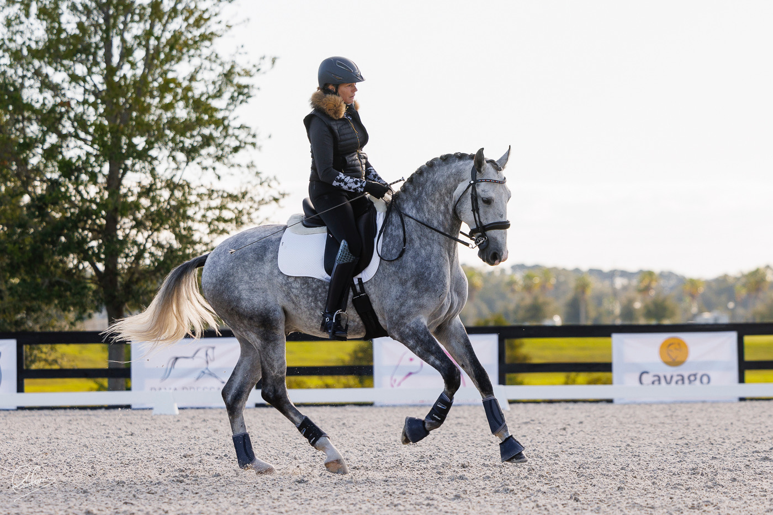

Holly Hill Equestrian Center Presents
3 day Working Equitation and Dressage Clinic
Trainer: Pati Pierucci
Dates: November 13-15, 2026 Location: Holly Hill Equestrian Center 1296 Old Plain Dealing Rd Benton LA 71006 https://hollyhillfarm.net Cost: 3 day clinic $375 This includes: 2 semi-private lessons with Ease of Handling (EOH) Obstacles and basic Dressage instruction 1 semi-private lesson for a full EOH course with instructional feedback as you go. 2 evening/educational dinners with demonstration rides from Pati. 1 goody bag.
Other possible formats: 2 Semi-Private Lessons: 280$ (Each lesson is 1hr and 10 min) 1 Private 45 min lesson: 185$ Individual Dinner/Education ticket 15$ Deposit 200$ Final Payment Due October 1 Contact Yevette Harrell ydharrelly@gmail.com 318-393-8336
Pati Pierucci is a respected FEI-level dressage rider, trainer, and clinician with over 30 years of experience. She holds USDF Bronze, Silver, and Gold Medals and was long-listed for the U.S. Olympic Selection Trials. Throughout her career, Pati has trained with top professionals including Betsy Steiner, Martin Schaudt, Christine Traurig, Kathy Connelly, and Robert Dover. She has been actively competing in Working Equitation since 2022 and is currently showing through the Masters level. She is on the high-performance rider list and is a hopeful contender for the U.S. team at the 2026 World Championships in Sevilla, Spain. Pati is known for her classical training approach, exceptional communication skills with both horses and riders, and her dedication to equestrian education across disciplines.

